Benford’s Law and Regression Results Published in
Articles in New Zealand Economic Papers

David E. Giles

June 2026

ONLINE APPENDIX A: Confidence Interval Plots for all Decade Sub-Samples

Figures 11(a), (b) to 13(a), (b) in the text provide plots of the confidence intervals for the 1st – digit and 2nd – digit empirical relative frequencies for the data relating to coefficients, standard errors and Student t-statistics just for the sub-sample for the 1990-199 decade. To save space, plots for the other decade sub-samples were not included. The plots for all of the decade sub-samples are provided in this document. Figures A.3(a) – A.3(f) correspond to Figures 11(a) to 13(b) in the paper itself.

1966 – 1979

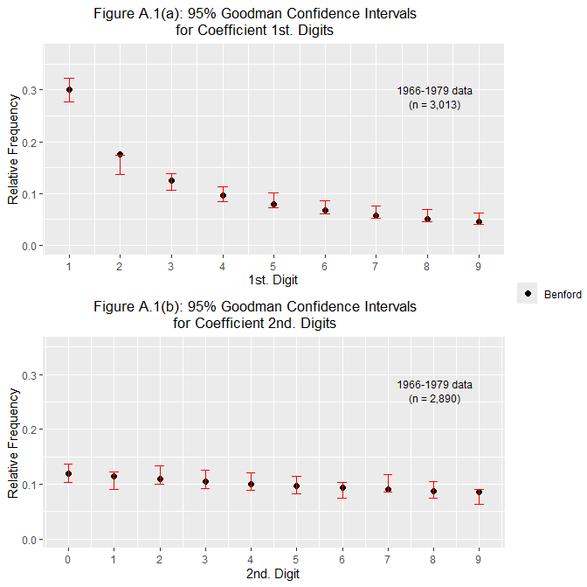

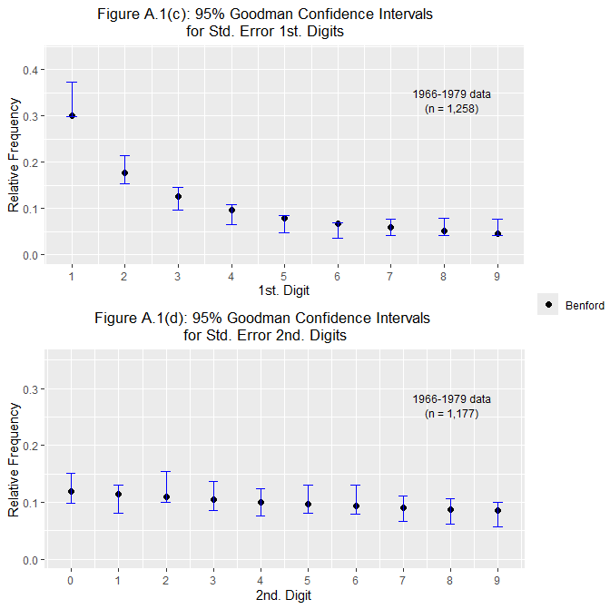

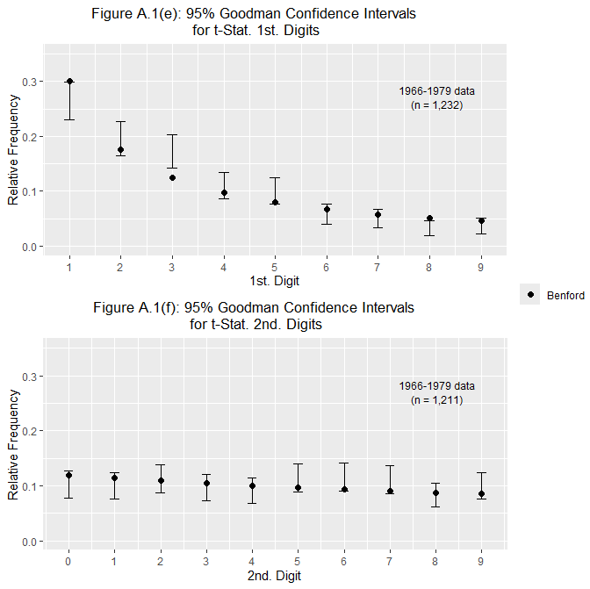

1980 – 1989

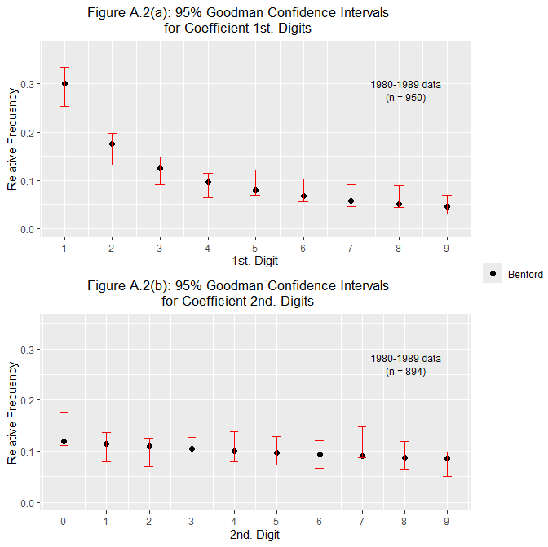

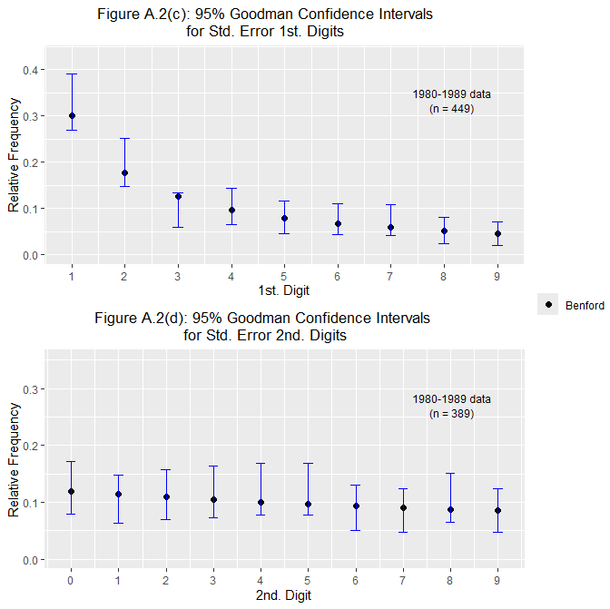

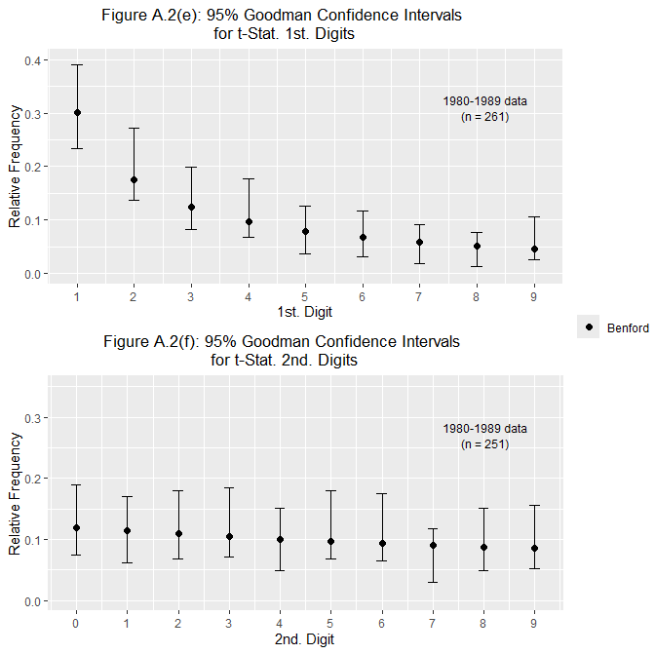

1990 – 1999

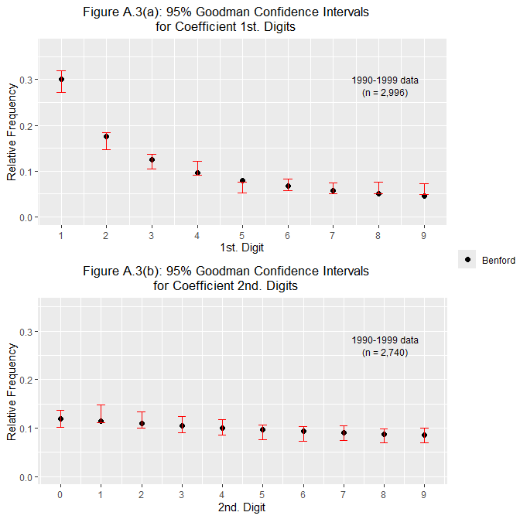

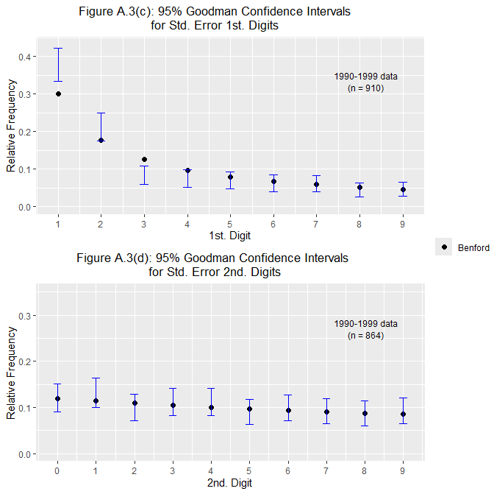

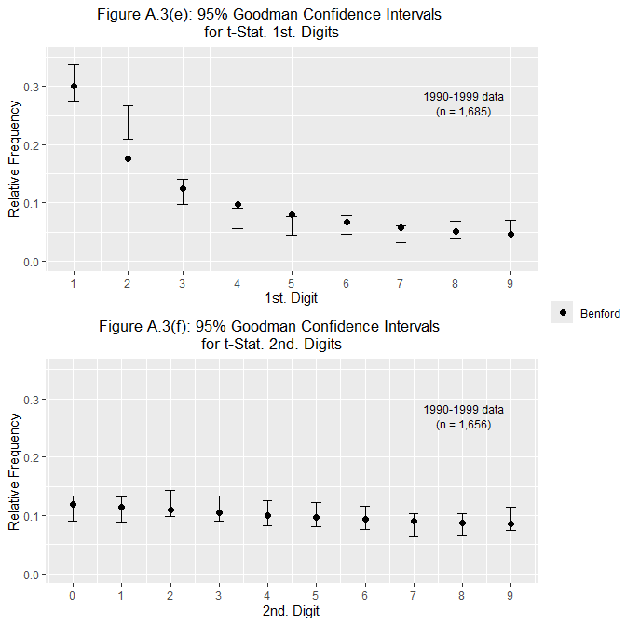

2000 – 2009

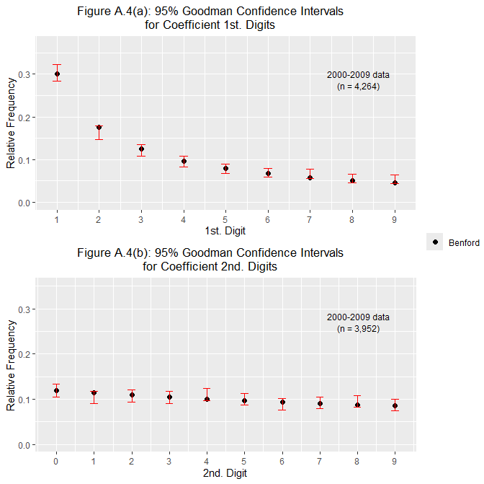

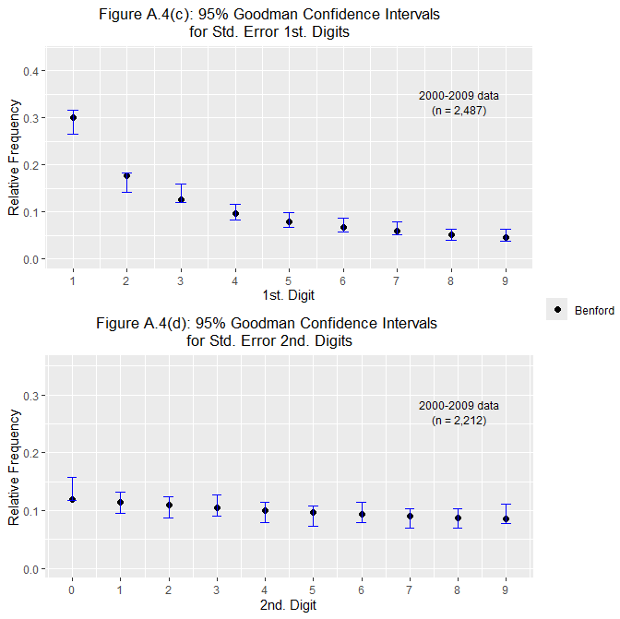

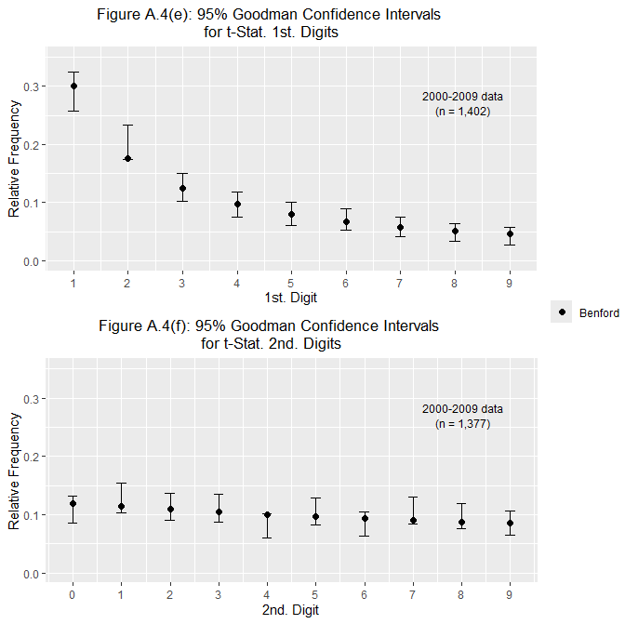

2010 – 2019

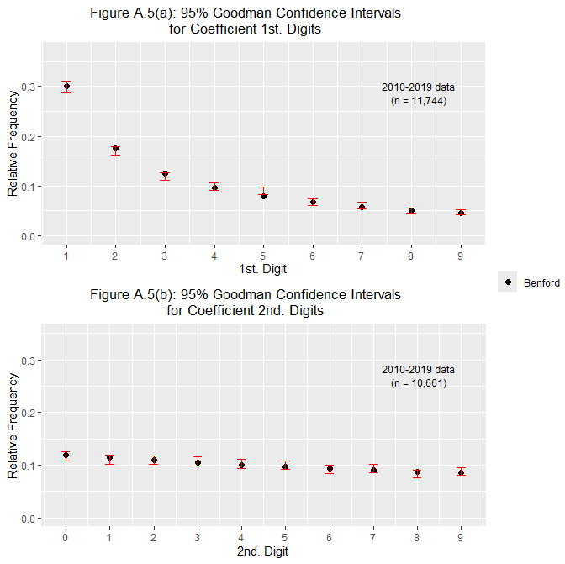

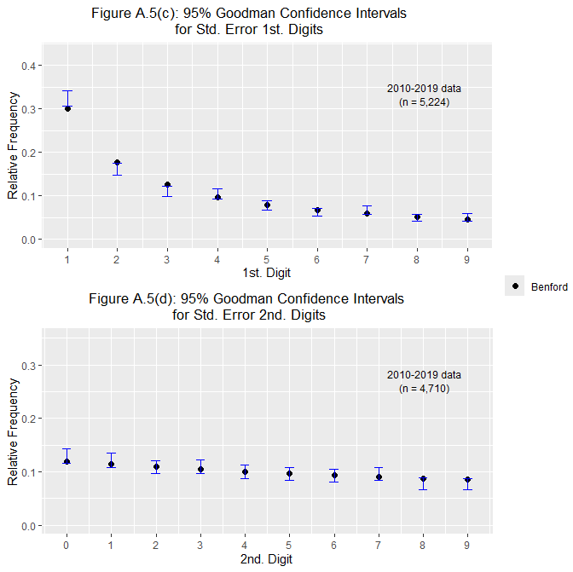

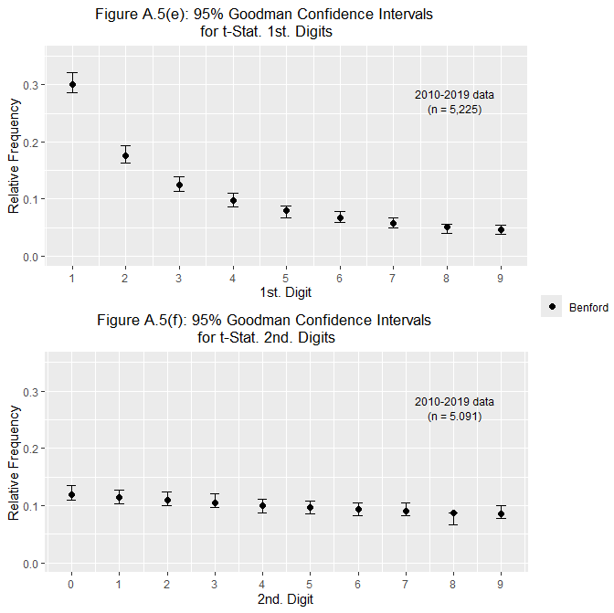

2020 – 2025

